Intro to confidence intervals
The main components of a confidence interval are a sample statistic, margin of error, and confidence level. Confidence intervals help express the uncertainty of an estimate based on sample data.
Way to express uncertainty.
Margin of error – maximum expected distance from the given number to the real number.
Margin of error = z-score * Standard Error
Confidence level – likelihood that a particular sampling method will produce a confidence interval that includes the population parameter.

The confidence level refers to the long-term success rate of the method, or the estimation process based on random sampling.

An interval estimate uses a range of values to estimate a population parameter.
Margin of error is the maximum expected difference between a population parameter and a sample estimate. Confidence level describes the likelihood that a particular sampling method will produce a confidence interval that includes the population parameter.

Construcy confidence intervals

-for a proportion
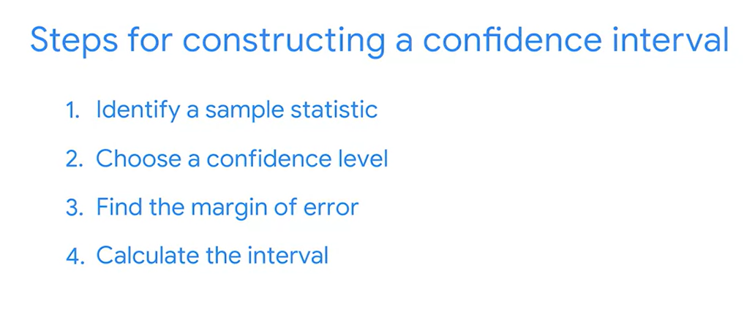

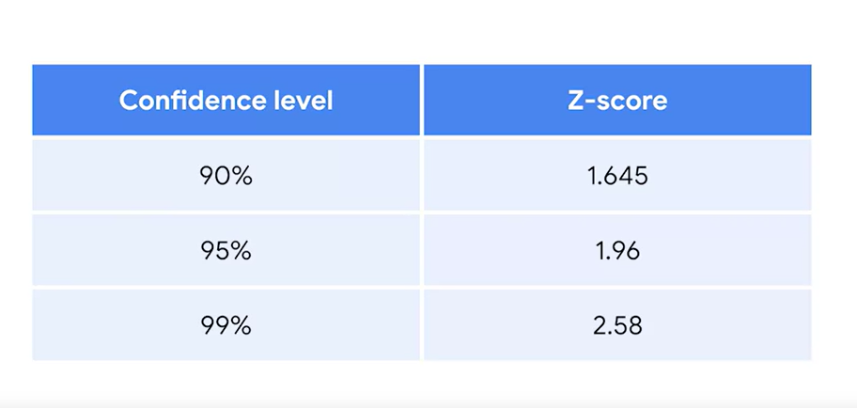
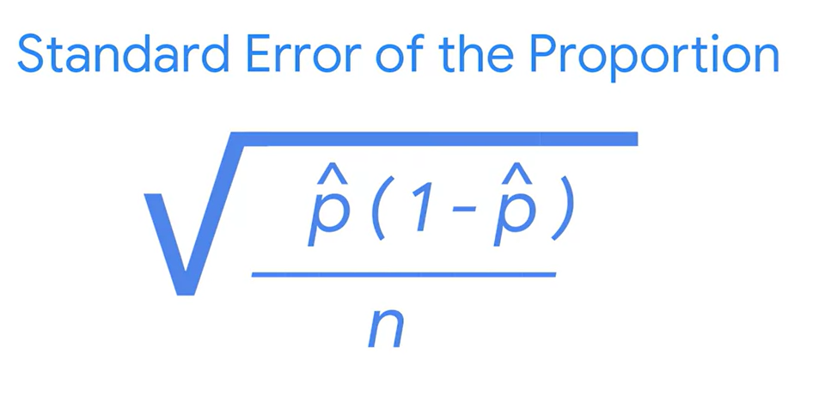

-for a mean
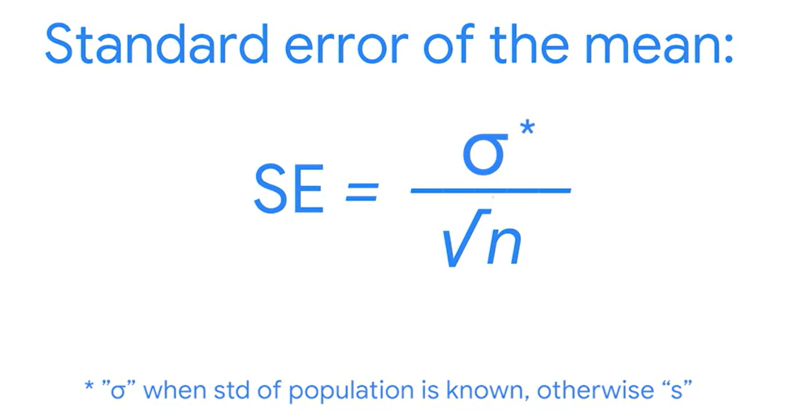
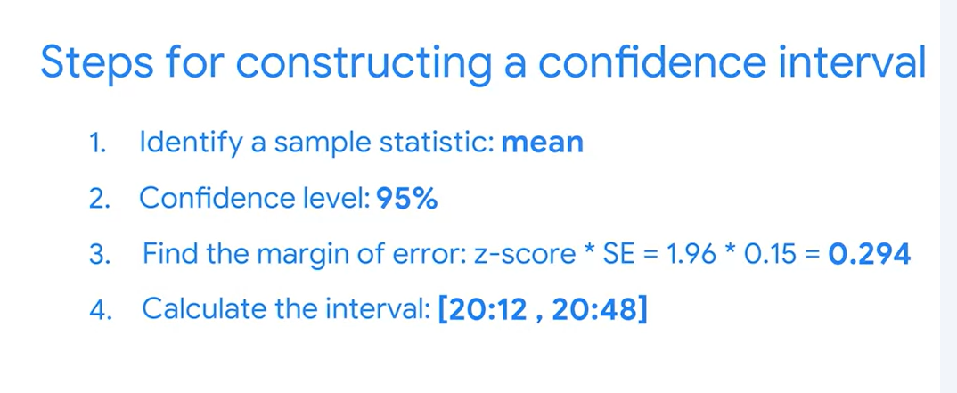

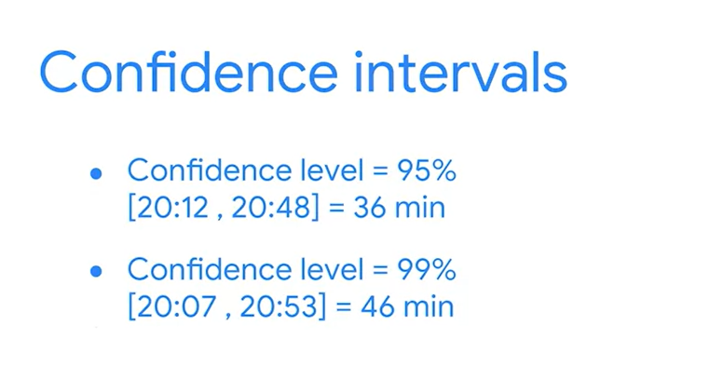
Bigger confidence intervals higher confidence level
- Construct a confidence interval for a small sample size
Typically, data professionals try to work with large sample sizes because they give more precise estimates. But, it’s not always possible to work with a large sample. In practice, collecting data is often expensive and time-consuming. If you don’t have the time, money, or resources to take a large sample, you may end up working with a small sample.
For large sample sizes, you use z-scores
For small sample sizes, you need to use a different distribution, called the t-distribution.
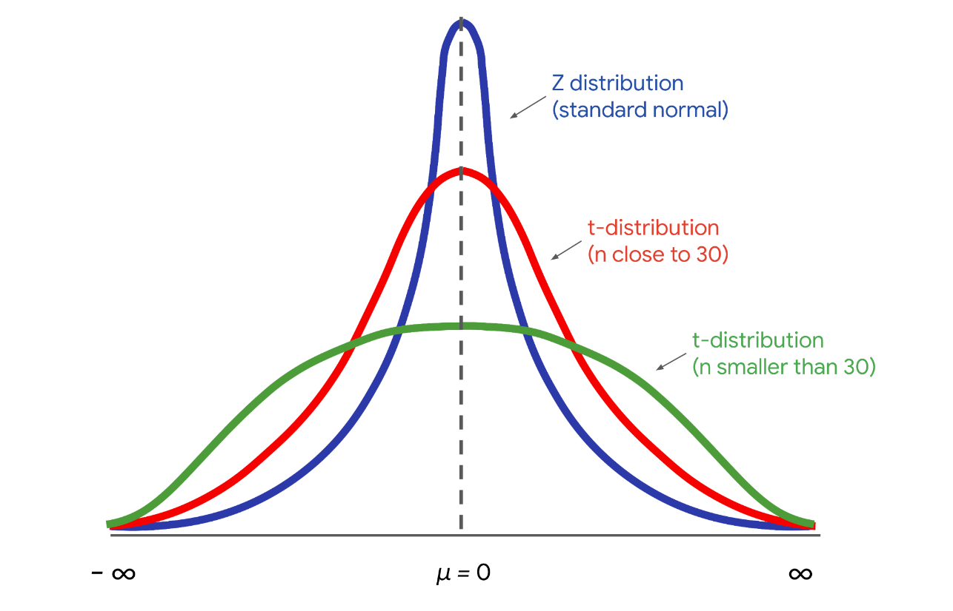

Example:
The engineering team tests a random sample of 15 engines and collects data on their emissions. The mean emission rate is 430 grams of CO₂ per mile, and the standard deviation is 35 grams of CO₂ per mile.
Your single sample may not provide the actual mean emissions rate for every engine. The population mean for emissions could be above or below 430 grams of CO₂ per mile. Even though you only have a small sample of engines, you can construct a confidence interval that likely includes the actual emission rate for a large population of engines. This will give your manager a better idea of the uncertainty in your estimate. It will also help the engineering team decide if they need to do more work on the engine to lower the emissions rate.
For a small sample size, you calculate the margin of error by multiplying the t-score by the standard error.
The t-distribution is defined by a parameter called the degree of freedom. In our context, the degree of freedom is the sample size - 1, or 15-1 = 14. Given your degree of freedom and your confidence level, you can use a programming language like Python or other statistical software to calculate your t-score.
Based on a degree of freedom of 14, and a confidence level of 95%, your t-score is 2.145.
Now you can calculate the standard error, which measures the variability of your sample statisti

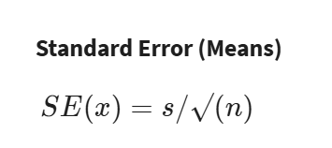
In the formula, the letter s refers to sample standard deviation, and the letter n refers to sample size.
Your sample standard deviation is 35, and your sample size is 15. The calculation gives you a standard error of about 9.04.
The margin of error is your t-score multiplied by your standard error. This is 2.145 * 9.04 = 19.39.
The upper limit of your interval is the sample mean plus the margin of error. This is 430 + 19.39 = 449.39 grams of CO₂ per mile.
The lower limit is the sample mean minus the margin of error. This is 430 − 19.39 = 410.61 grams of CO₂ per mile.
You have a 95% confidence interval that stretches from 410.61 grams of CO₂ per mile to 449.39 grams of CO₂ per mile.
95 CI [410.61, 449.39]

